Tarot Tales by Rashmi

Menu’s
HomeAboutServicesTestimonialsContact

About
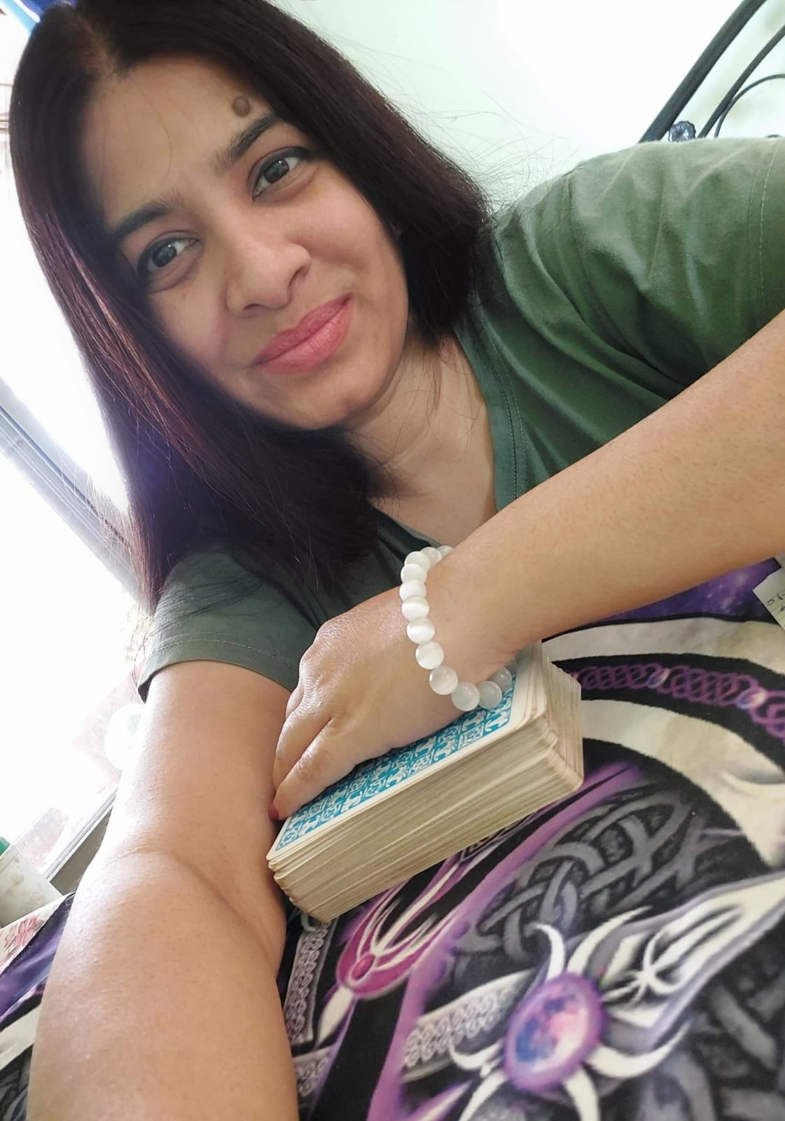

Atma Namaste,
I’m Rashmi, a Certified 🌻Tarot Reader 🌻Reiki Master 🌻Lama Fera Healer with over 12 years of experience.
As a clairvoyant, my passion lies in helping individuals uncover their true potential and lead more fulfilling lives. My spiritual journey began at a young age, and over the years, I’ve immersed myself in various modalities to deepen my understanding of the mind-body-spirit connection. This extensive experience has enabled me to craft a personalized healing approach for each of my clients.

Tarot Reading: I use Tarot as a tool for insight, reflection, and self-discovery, helping you understand your current situation, recognize the energies influencing your life, and make informed decisions for your future. Every reading is approached with compassion, honesty, and respect for your unique journey, ensuring confidentiality and trust.
Reiki Healing: As a Certified Reiki Grandmaster, I channel healing energy to restore balance, relaxation, and well-being. My approach combines traditional Reiki techniques with intuitive healing to release negative energy, emotional blockages, and support your body’s natural healing processes.
I believe in the unique power of every individual to shape their reality. That's why I offer tailored, personalized services that address your specific needs and preferences. Virtual consultations are available for your convenience. Whether you seek guidance, healing, or self-discovery, I’m here to support you on your transformative journey.
Thank you for considering my services. I look forward to helping you achieve greater balance, fulfilment, and overall well-being.
“My mission is to simplify, uplift, and enhance the lives of my clients.”

Contact
For In-person or Online Appointments
Location:
Mumbai, India.
Contact:
Tel:+91 7400110582
Email:tarottales2@gmail.com

Follow Us On:

YouTube Channel: | www.youtube.com/@tarottalesbyrashmi

Instagram: https://www.instagram.com/tarottalesbyrashmi/

Facebook: https://www.facebook.com/rayoflight.spiritual

WhatsApp Channel : whatsapp.com/channel/0029Vb2EQDHBvvsefoWM8w0B

Services
Reading
- Angelic /Oracle/Tarot Reading (General reading, Relationship/Marriage, Health, Spirituality, Job/Business/Finance)
- Astro Tarot Reading for family
- Sand Reading
- Candle Wax Reading
- Dowsing

Healing
- Reiki healing (Traditional, Karuna, Dolphine, Tiger, Rainbow)
- Lama Fera
- Psychic Surgery
- DNA Reiki

Learn
- Reiki Level 1
- Reiki Level 2
- Reiki Level 3
- Mastel Level
- Karuna Reiki
- Angelic Reiki
- Money Reiki
- Dolphin Reiki
- Magic Reiki
- Afformation
- Dowsing
- Sigil Creation
- Lama Fera (Basic level)

In this section its description image and time and price arrange acc to u

Testimonials
Words of praise by my valuable clients.

